5). Create a simple cloud software application for Mark Sheet Processing System using any Cloud Service Provider to demonstrate SaaS include the necessary fields such as name of the student, Reg no of the student, Subjects , Marks, Average, percentage, rank, overall performance etc.

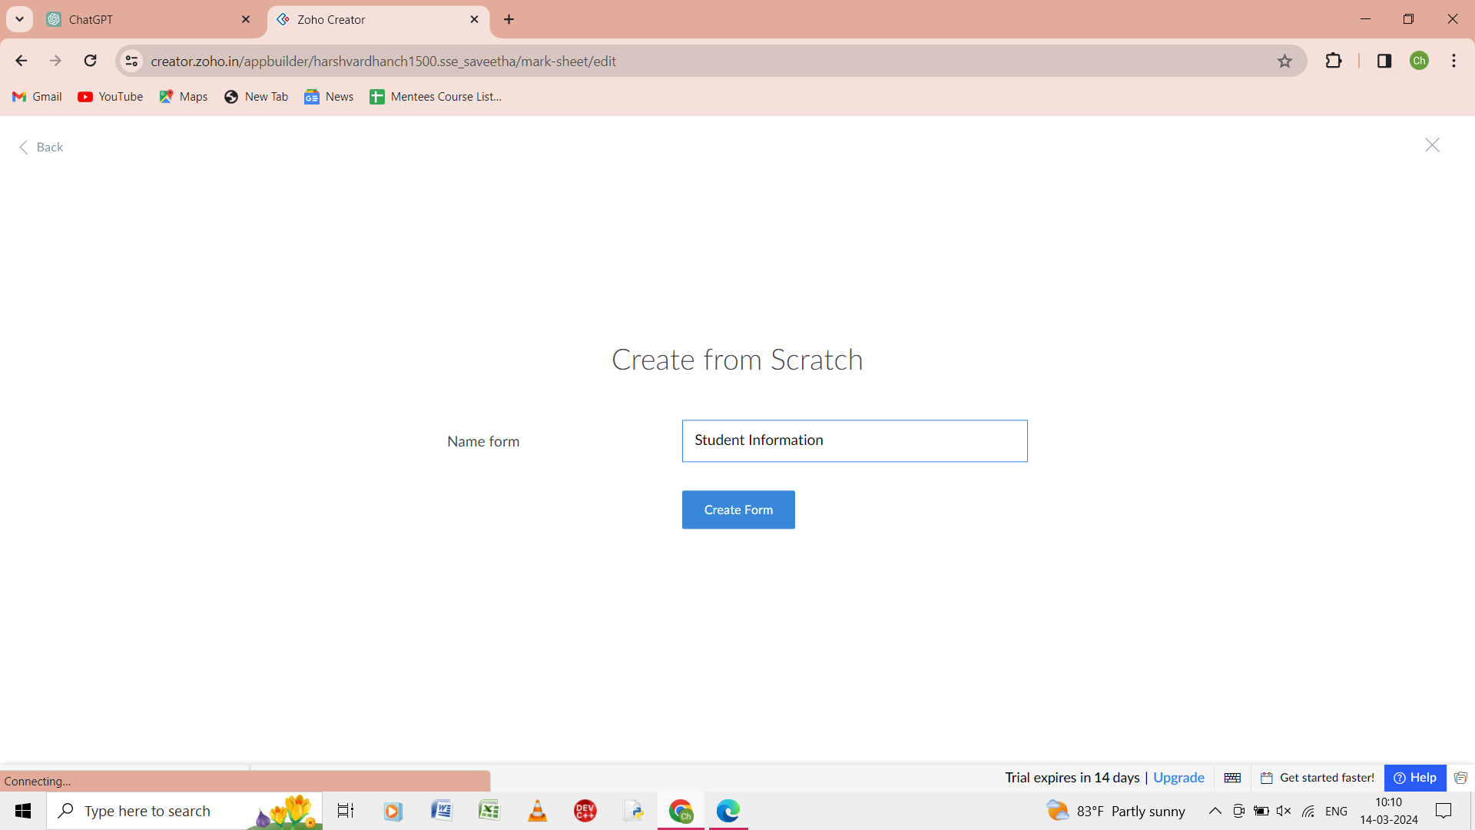

Step 1: from the scratch give the form of the name as student information.

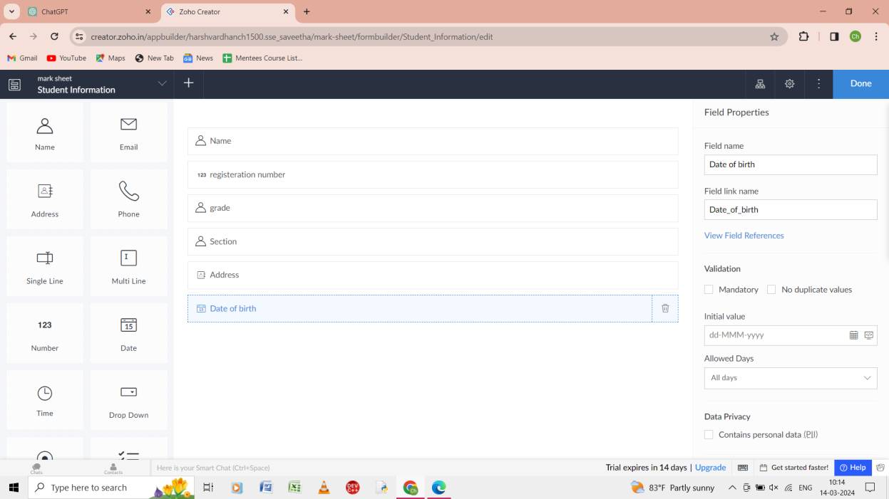

Step 2: In the form student information there name, register number, grade, section, address, date of birth.

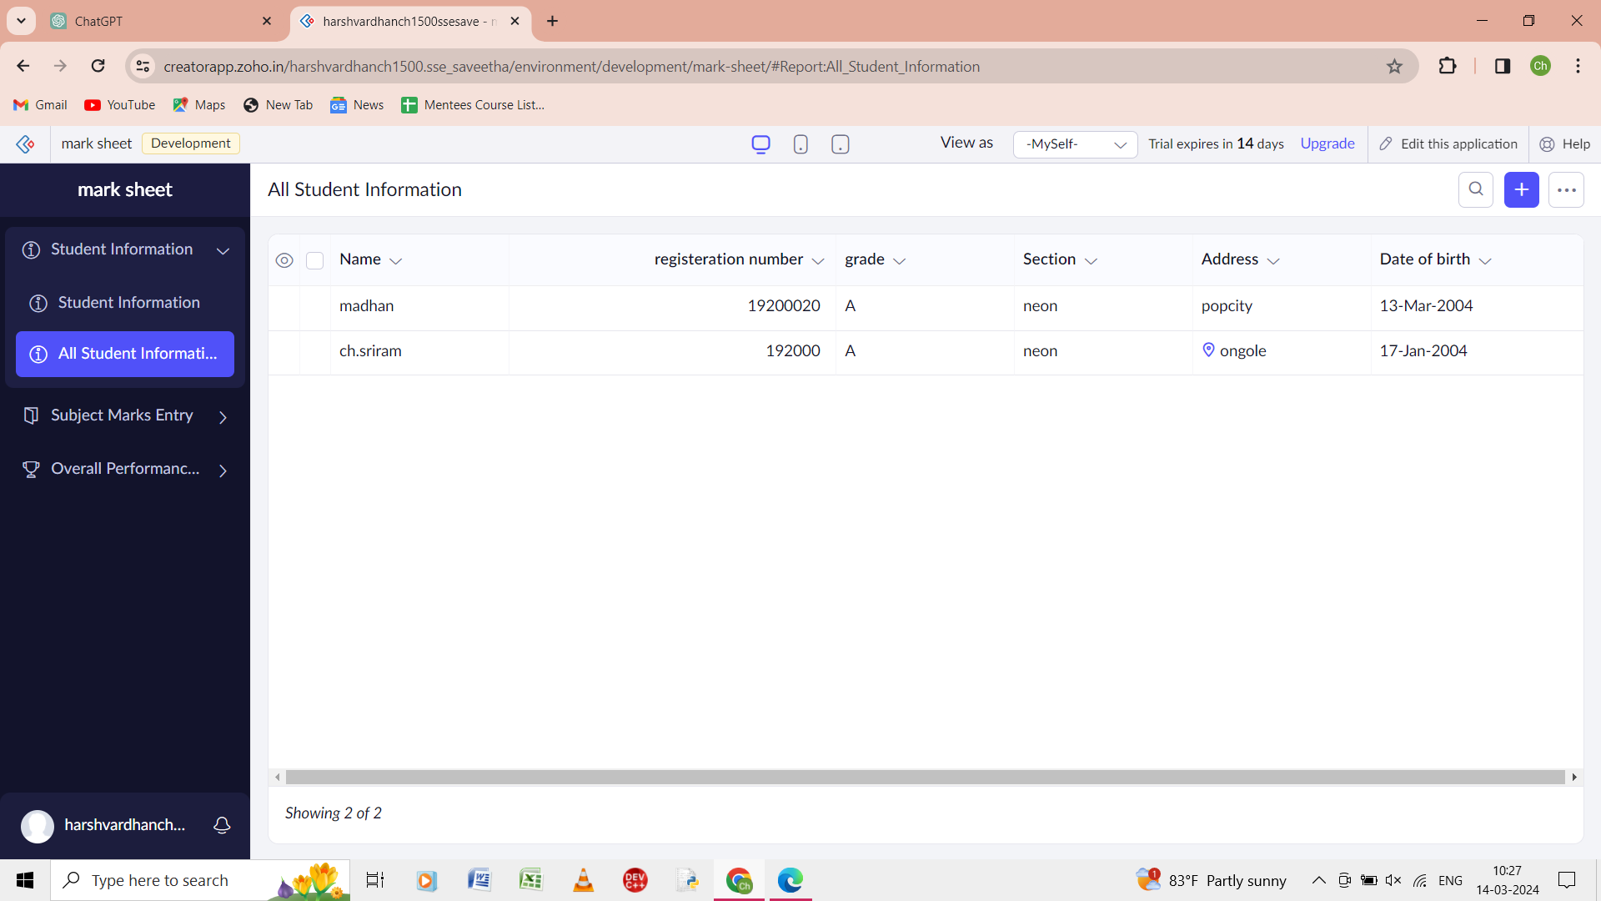

Step 3: all the student information of the form is given in the report.

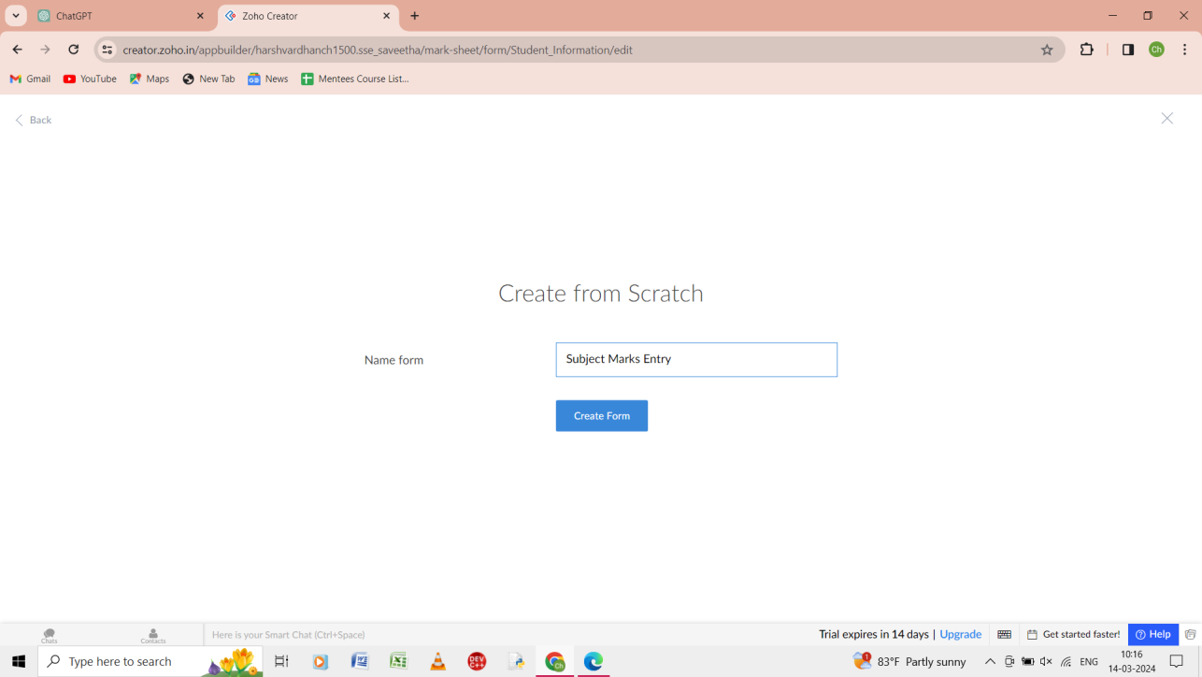

Step 4: from the scratch give the name of the application as the subject marks entry.

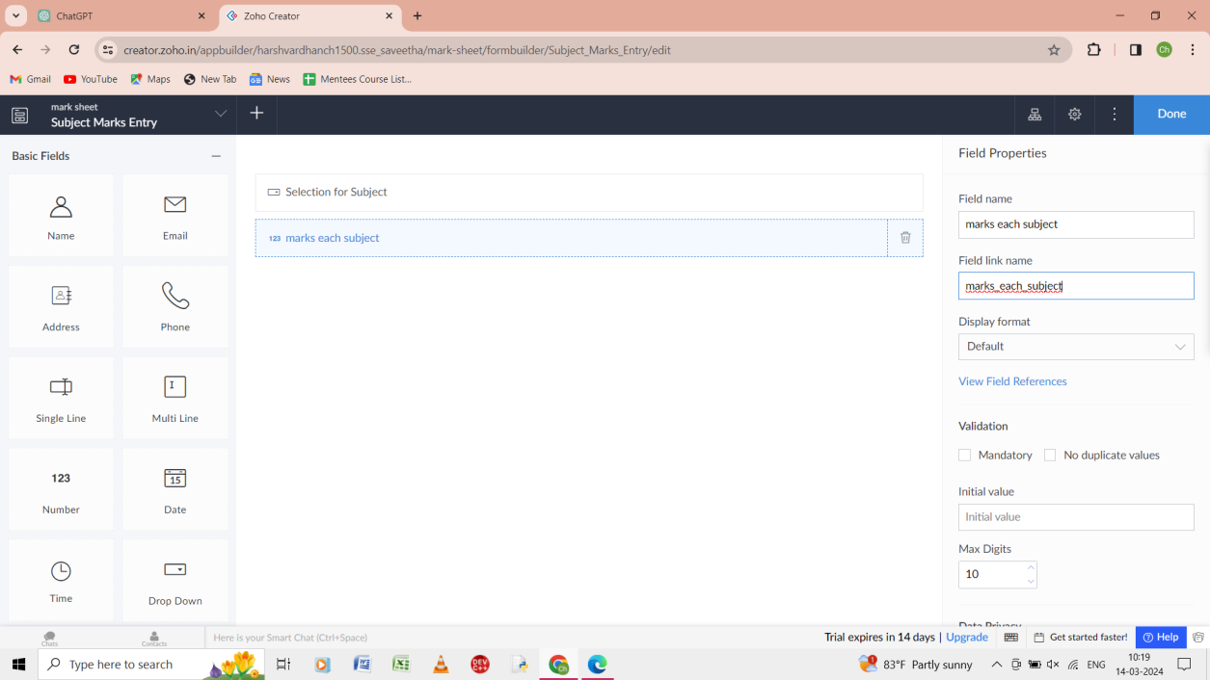

Step 5: give the input as the marks for the subjects.

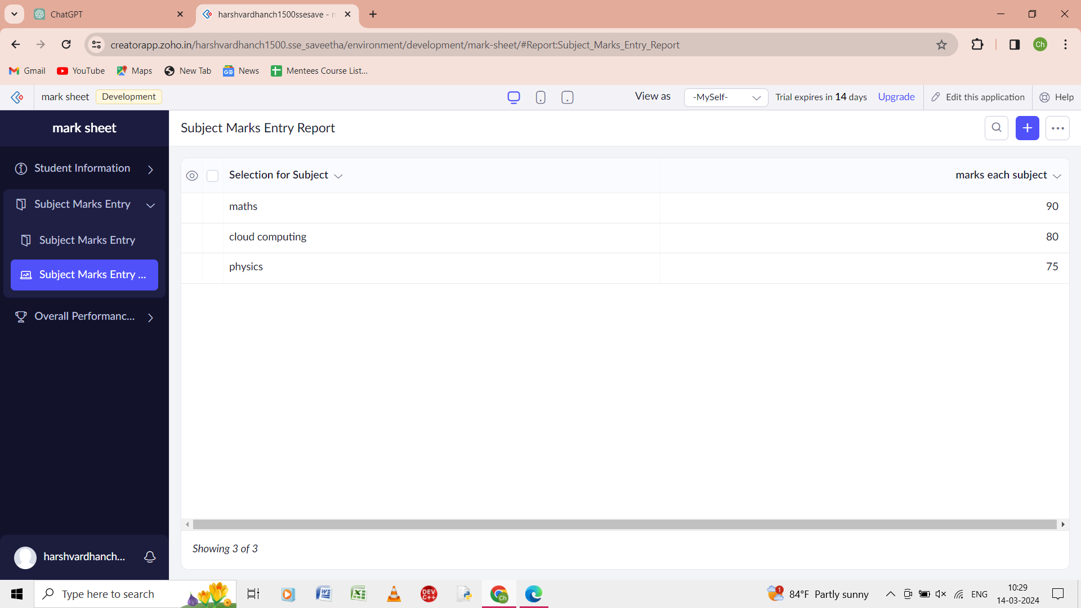

Step 6: enter the marks for the each subject in the input of the form.

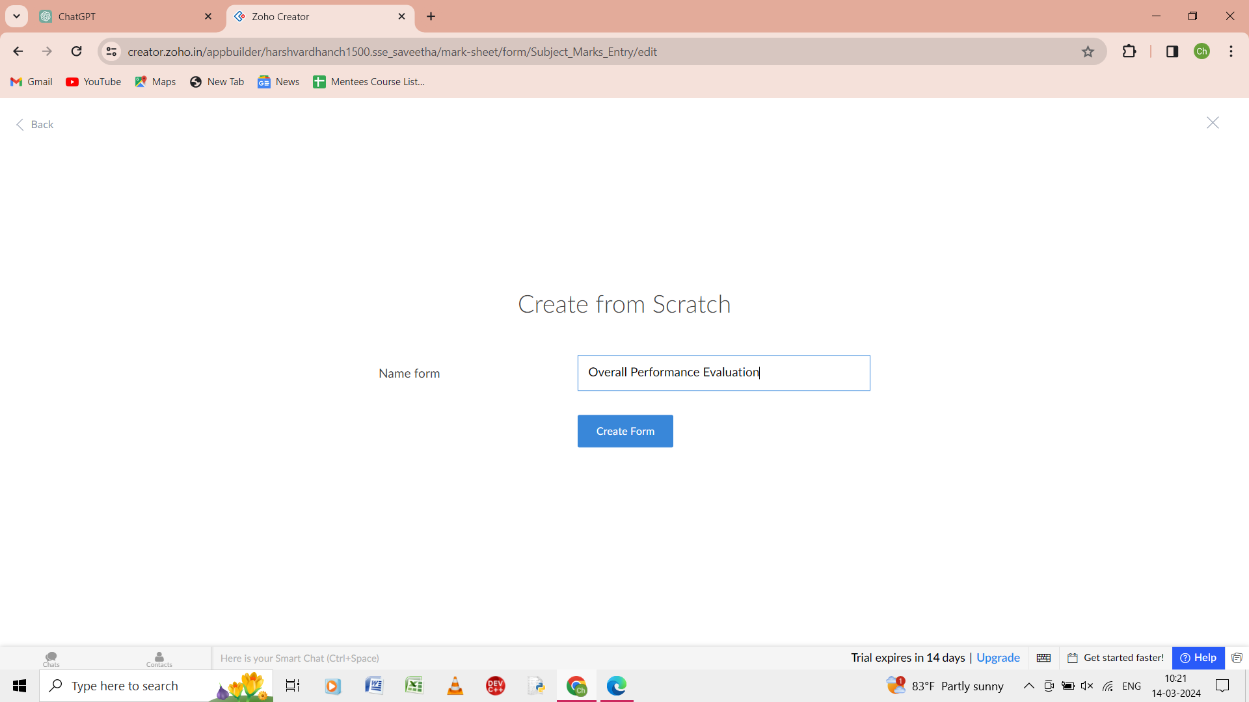

Step 7: from the scratch give the form name as the overall performance evaluation.

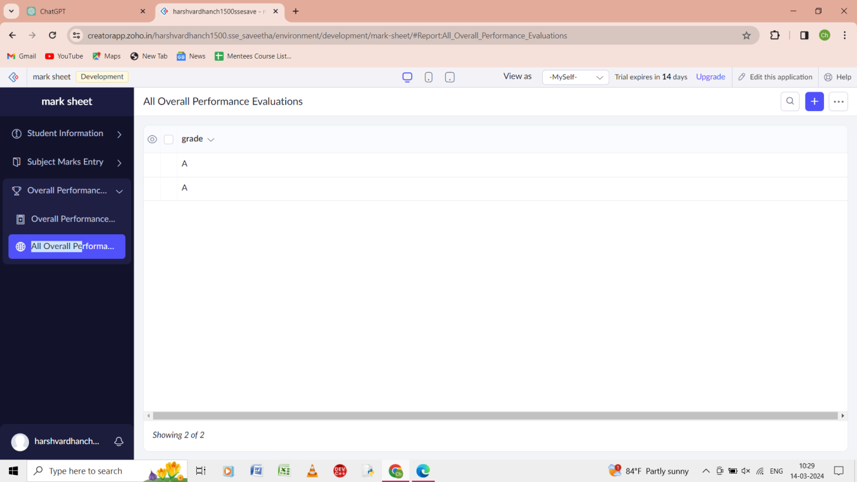

Step 8: give the grade for the form as overall performance of the student.